9.14: a) The average angular velocity is 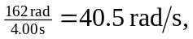 and so the initial angular velocity is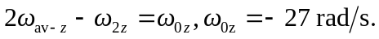
b) 